
csci222 ASSIGNMENT 1 REPORT

Team Number : < 4 >

 | Student Number | Name | Email Address
1 |  | (Team Leader)  Nguyen Duc Anh | Tel :  Email :
2 |  | William Wunady
3 |  | Ardyanto
4 | 4948403 | Wu Chin Hwa | ft_wu_chin_hwa@yahoo.com
5

February 13, 2016
University of Wollongong

Table of Contents
Project Overview 3
1. Vision 3
2. Initial Use-case Model 4
3. Requirement List 4
User Requirements: 5
System Requirements: 6
4. Project Plan 7
Roles and Responsibility 9
Risk Analysis and Counter Measures 10
Design Artefacts - Use Cases (Iteration 1) 12
Design Artefacts - Use Cases (Iteration 2) 13
Design Artefacts - Activity Workflows (Iteration 1) #1 14
Design Artefacts - Activity Workflows (Iteration 1) #2 15
Design Artefacts - Activity Workflows (Iteration 1) #3 16
Design Artefacts - Activity Workflows (Iteration 1) #4 17
Design Artefacts - Activity Workflows (Iteration 1) #5 18
Design Artefacts - Activity Workflows (Iteration 1) #6 19
Design Artefacts - Activity Workflows (Iteration 1) #7 20
Design Artefacts - Activity Workflows (Iteration 1) #8 21
Design Artefacts - Activity Workflows (Iteration 1) #9 22
Design Artefacts - Activity Workflows (Iteration 2) #1 23
Design Artefacts - Activity Workflows (Iteration 2) #2 24
Design Artefacts - Activity Workflows (Iteration 2) #3 25
Design Artefacts - Activity Workflows (Iteration 2) #4 26
Design Artefacts - Activity Workflows (Iteration 2) #5 27
Design Artefacts - Activity Workflows (Iteration 2) #6 28
Design Artefacts - Activity Workflows (Iteration 2) #7 29
Design Artefacts - Activity Workflows (Iteration 2) #8 30
Design Artefacts - Activity Workflows (Iteration 2) #9 31
Appendix A - Formal Meeting Records 36
Inception Phase - Iteration 1 36
Elaboration Phase - Iteration 1 36
Elaboration Phase - Iteration 2 36
Appendix B - Individual Work Diaries 38
Team Member 1: Nguyen Duc Anh 38
Inception Phase - Iteration 1 38
Elaboration Phase - Iteration 1 38
Elaboration Phase - Iteration 2 38
Team Member 2: William Wunady 39
Inception Phase - Iteration 1 39
Elaboration Phase - Iteration 1 39
Elaboration Phase - Iteration 2 39
Team Member 3: Ardyanto 40
Inception Phase - Iteration 1 40
Elaboration Phase - Iteration 1 40
Elaboration Phase - Iteration 2 40
Team Member 3: Wu Chin Hwa 41
Inception Phase - Iteration 1 41
Elaboration Phase - Iteration 1 41
Elaboration Phase - Iteration 2 41
Appendix C - Evidence of using VCS (Version Control Software) 42

Project Overview

Name of product : Country Club Facilities Booking System (CCFBS)
Date established : February 24th 2016 (Is it 2015 or 2016?)
No. of participant : 4

Production

The project used to develop a Country Club Facilities Booking System with the help of Rational Unified Process (RUP) and in this report we will be more focus on Inception and Elaboration phase.

This project is done by communication between the team member, management by the team leader and work by each member as their assigned roles. Both from Online Chatting (preferably by Facebook) and formal real life meeting were used as the project communication. Each team member worked on specific section based on their specialty.

Vision
- Main task: Our main objective of this project is to create a Country Club Facilities Book System (CCFBS) that helps club member to access the booking facilities via electronic devices. The system must allow the club member to book or search available facilities. Club manager (stake holders) also can access the system to constantly update the facilities and process any booking issued by club members.
- Scope and features: Club member can search through any available facilities by their preferred criteria and book the facilities via the system. Club member can also view and edit their personal information. Club manager as the stake holders can manage the facilities by creating new facilities, updating or deleting an existing facility while also processing any booking from the club members. The admin of the system has the highest authority which can add or delete any club member or club manager.
- Constraint: The system is a virtual database for storing any information of the club members, managers, facilities and booking information. It needs a basic GUI for any user to easily understand and a good protection from any data loss.

Initial Use-case Model
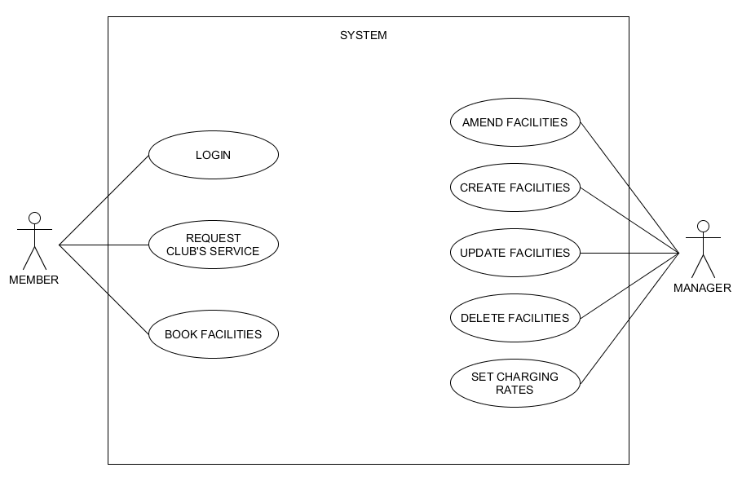

This is our initial use-case model based on our initial understanding on the project requirement of the system and it shows basic relationship between manager and the member to the system. This is only a brief understanding of the entire system and after analysing the requirement, we came up with the requirement list for this project.

Requirement List

We split the requirement list into two major component which are the user requirement and the system requirement. In the user requirement, we will cover the requirement needed by the club member, club manager and the system admin. System requirement covers the basic functionality of the system while some of them are not mandatory. As this project is still ongoing project, we may have not implemented all the function required and in the future we may drop some of them depending on the priority.

User Requirements:
(Is it empty on purpose or not done yet?)

- Club member:

Requested Functionality | Implemented
A Club member must be able to log into the system. | 100%
A Club member must be able to book or search a club facility. | 100%
A Club member must be able to choose a club facility from a list. | 100%
A Club member must be able to choose the time of booking. | 100%
A Club member must be able to choose the duration of booking. | 100%
A Club member must be able to view the booking they have made with the system (status, which facility booked, duration of booking, etc.) | 100%
A Club member must be able to log out of the system. | 100%
A Club member must be able to view their own personal details. | 100%
A Club member must be able to set and modify their own personal details | 100%
A Club member must be able to cancel their booking. | 0%
A Club member must be able to book club facilities for people besides themselves. | 0%

- Club manager:

Requested Functionality | Implemented
A Club manager must be able to give membership rankings towards club members. | 100%
A Club manager must be able to edit own details. | 100%
A Club manager must be able to log into the system. | 100%
A Club manager must be able to view all bookings made for Club members. | 100%
A Club manager must be able to process booking | 100%
A Club manager must be able to give special privileges to Club members based on their membership rankings. | 0%
A Club manager must be able to give discounts entitlement pertaining to club’s Search systems (using karaoke, playing billiard, etc) | 100%

Requested Functionality | Implemented
A Club manager must be able to log into the system. | 100%
A Club manager must be able to view a Club member’s personal details. | 100%
A Club manager must be able to view a Club member’s booking details.
A Club manager must be able to search for a Club member. | 100%

Requested Functionality | Implemented
A Club manager must be able to view information related to club facilities.
A Club manager must be able to create, delete, amend and update a club’s facilities for booking.
A Club manager must be able to set various charging rates based on peak and off-peak periods.

Requested Functionality | Implemented
A Club manager must be able to modify a club member’s membership rankings and privileges. | 0%
A Club manager should be able to notify club members whenever their booking starts or ends. | 0%

- Admin:

Requested Functionality | Implemented
An Admin must be able to add new club member or club manager
An Admin must be able to access all other functionality of the system.

System Requirements:

Requested Functionality | Implemented
The system requires a persistent data model (#58 in SRS).
The system must alert Club facilities managers if a ‘watch’ status Club member has booked a flight.
The system must prevent a ‘no-booking’ status Club member from booking a facility.
The system must charge Club members a cancelation fee if they cancel a facility booking.
The system must keep records of a Club member’s cancelled bookings as well as currently booked facilities.
The system should provide a GUI to all users. [LOW PRIORITY] | NOT DOING
Multiple users should be able to access the system concurrently. [LOW PRIORITY] | NOT DOING
The System should run on Windows and/or VMWare Ubuntu. | 100%
Alerts should be issued to Club members that are booked on a flight that has been cancelled by the club facilities manager.
Reports should be interesting computations and compilations of data used by the system. Provide informative information to the company managers.
Club members who book through a friend (another club member) must provide the system all the same details that are required in a normal Club member registration.
During a booking, the Club member should receive a list of facilities yet unbooked that includes facilities up to a week away from the search date.
A Club member should have the option to revise booking details before confirming.
Passwords must be hidden by asterisks. | NOT DOING
The user interface should be in English language.

Project Plan

- Week 1: (Do we need to explain what happen on the week 1, 2, and 3?)

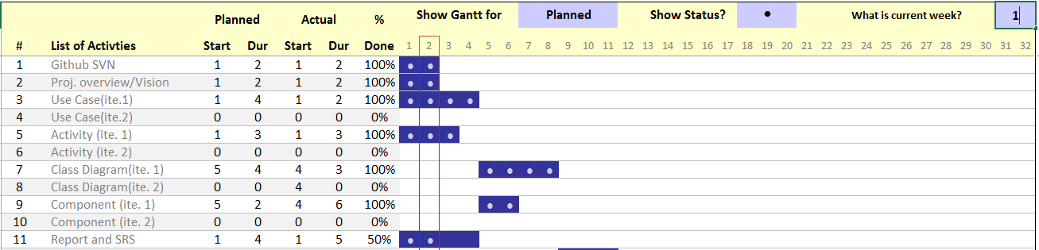

- Week 2:

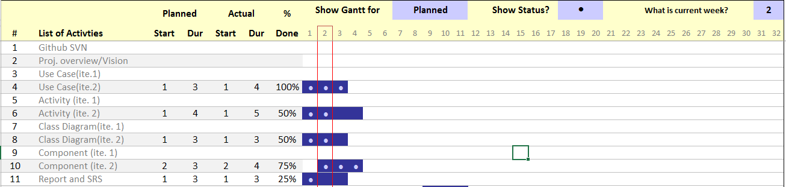
- Week 3:

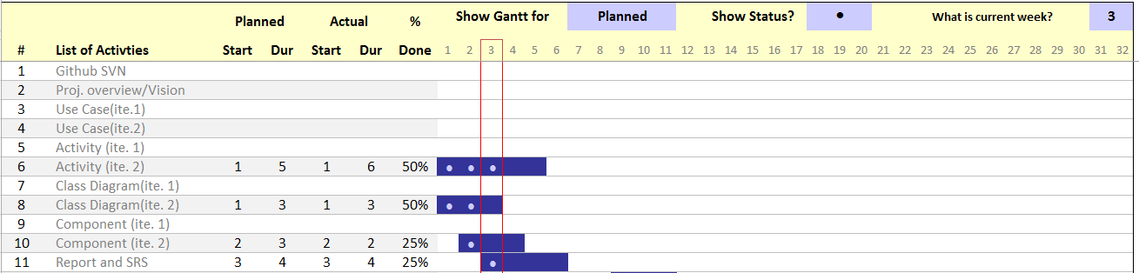

Roles and Responsibility

Team Number: < 4 > (Feel free to add or remove your role and artefact!)

 | Student Name | Role | Artefacts
1 | Nguyen Duc Anh | Project manager, Sub-designer | Use-case diagram, Class diagram, Component diagram, part of SRS and project planning.
2 | William Wunady | Sub-manager, Project analyst | SRS, project planning, scheduling and some part of other diagrams.
3 | Ardyanto | Project designer, Sub-analyst | Use-case diagram, Activity diagram and case analyzing
4 | Wu Chin Hwa | Project analyst, Sub-designer, Documenter and Reviser | Use-case diagram, Activity diagram, Risk Management Plan and Report
5

Risk Analysis and Counter Measures

RISKS
 | Impact Type | Risk of Seriousness (%) | Likelihood of Occurrence (%) | WBS (affected work/task) | Risk Description
1 | Budget | 70% | 10% | All | Some or all project’s team members may demand a higher pay which can result on the project being halt.
2 | Deadline | 80% | 10% | All | Some of the team’s member may resign in the middle of the process or will lower the quality of the project if rushed.
3 | Technology Problem | 90% | 5% | All | System error may slow down the project process and consume more time to fix it.
 |  |  |  |  | System crash may result in the loss of data which may move the project several step back.
4 | Document Problem | 30% | 5% | All | Wrong documentation can create some major confusion in the team’s members and it will increase the workloads. If it’s a document lost, it can potentially cause the project to move several step back.
5 | Personal Problem | 10% - 80%  (Depending on the person’s position and problem) | 5% | All | If a team’s member suddenly face a personal problem such as family matter or relationship problem, it can reduce the performance or in the worst case, the member will resign from the project.
6 | Requirement Changes | 10% - 70% (Depending on the changes) | 10% | All | If somehow the project manager or the director ask for some changes in the project, it will cause some problem depending on the changes. If the changes is big, probably the effort and the time consumed will be null. It also can increase the time consumption to finish the project thus missing the deadline. The changes can come from the company itself or by customer’s demand.

COUNTER MEASURES
 | Risk Description | Proposed Management Plan | (Possible) Reduction in Risk Seriousness (%)
1 | Some or all project’s team members may demand a higher pay which can result on the project being halt. | Plan 1: Offers the pay demanded by the team’s members. | -75%
1 |  | Plan 2: Fire some members that demand higher pay then find fill the missing position. | -25%
1 |  | Plan 3: Reduce the workload per individual and hire more members that are willing to work on the project. | -35%
2 | Some of the team’s member may resign in the middle of the process or will lower the quality of the project if rushed. | Plan 1: Reduce the workload per individual and hire more members that are willing to work on the project. | -50%
2 |  | Plan 2: Extend the deadline | -50%
3 | System error may slow down the project process and consume more time to fix it. | Plan 1: Do some regular (daily or weekly) maintenance on any electronic during the time outside the work period. | -80%
3 | System crash may result in the loss of data which may move the project several step back. | Plan 1: Back up the data after the work daily on one or more computers. | -80%
4 | Wrong documentation can create some major confusion in the team’s members and it will increase the workloads. If it’s a document lost, it can potentially cause the project to move several step back. | Plan 1: Keep track of all documents created and store them according to the type and purpose. | -20%
4 |  | Plan 2: Hire an experienced and professional documentarist. | -25%
5 | If a team’s member suddenly face a personal problem such as family matter or relationship problem, it can reduce the performance or in the worst case, the member will resign from the project. | Plan 1: Regular check-up or meeting with the team’s member. | -50%
5 |  | Plan 2: Find a replacement or hire a new employee. | -50%
6 | If somehow the project manager or the director ask for some changes in the project, it will cause some problem depending on the changes. If the changes is big, probably the effort and the time consumed will be null. It also can increase the time consumption to finish the project thus missing the deadline. The changes can come from the company itself or by customer’s demand. | Plan 1: Regular briefing and meeting between the members. | -60%
6 |  | Plan 2: Work out all of the possibilities change | -25%

Design Artefacts - Use Cases (Iteration 1)

(Any explanation….?)

Design Artefacts - Use Cases (Iteration 2)

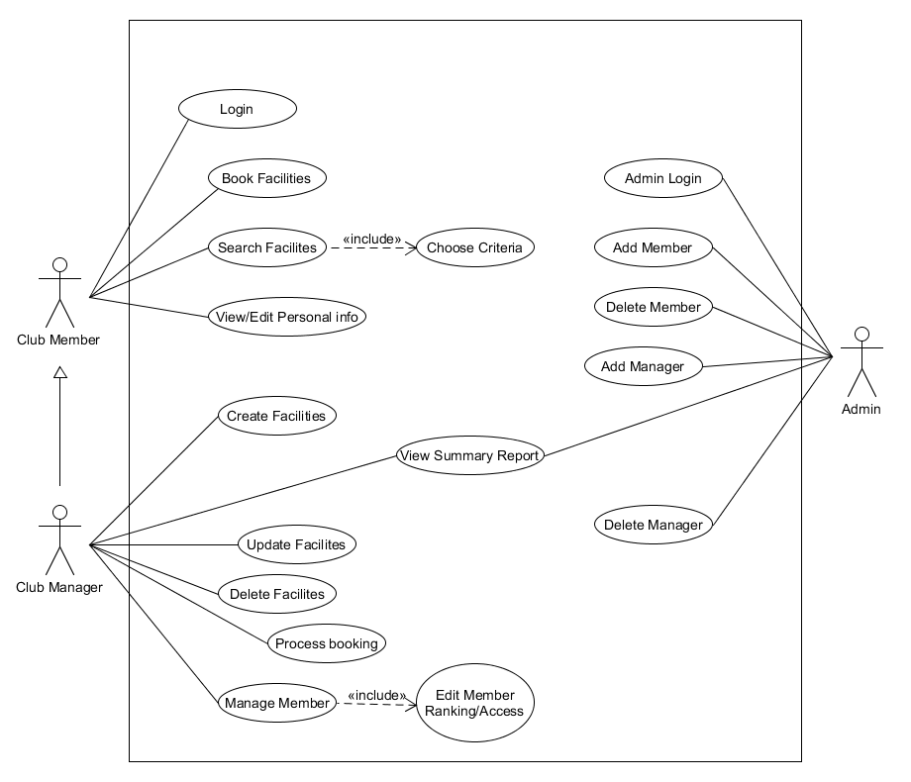

(Any explanation….?)

Design Artefacts - Activity Workflows (Iteration 1) #1

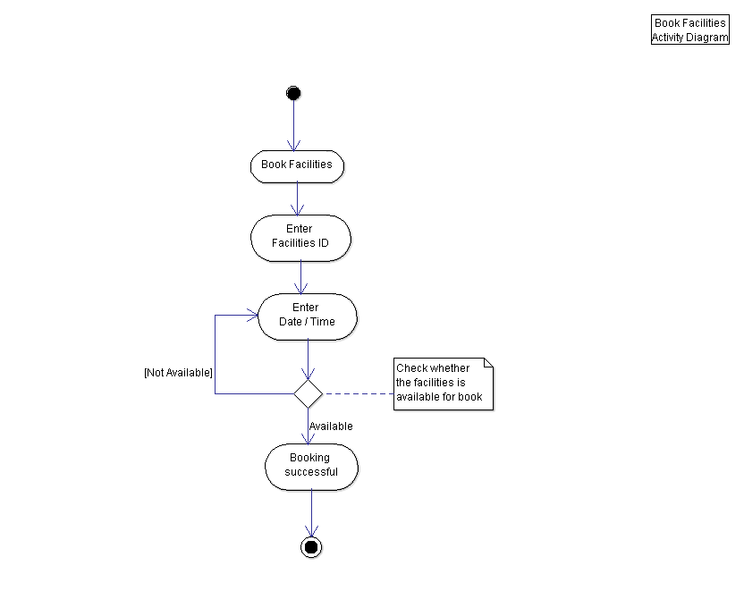

Work flow:
This is an activity flow diagram for Booking Facilities by the Club Member. The club member will start by choosing “Book Facilities” option then proceed to enter the facility’s ID and include the date and time for the book. The system then will check if the facility is available for booking during the specified time and date. It returns the user to enter date and time when not available and it will notify the user when succeeded on booking.

(Remove above explanation if too lazy to add another explanation on each activity diagram!)

Design Artefacts - Activity Workflows (Iteration 1) #2

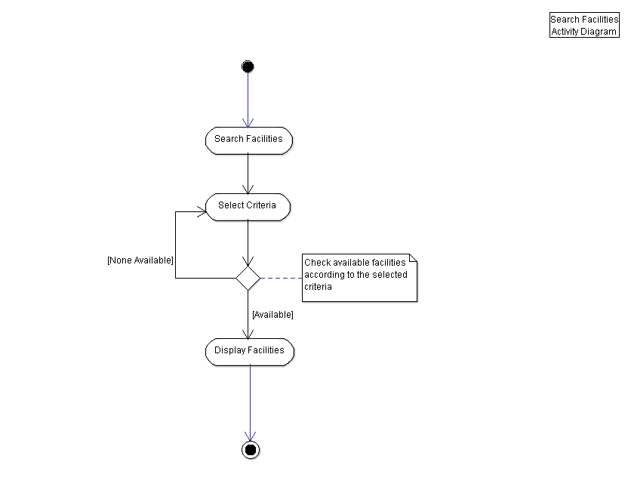

Design Artefacts - Activity Workflows (Iteration 1) #3

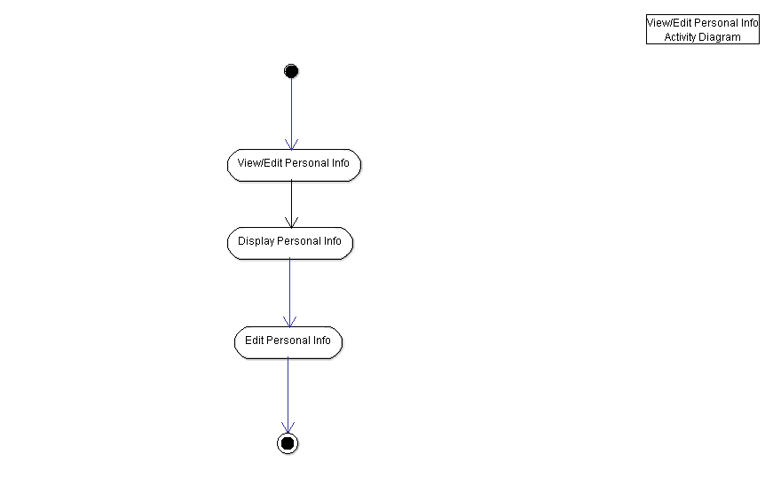

Design Artefacts - Activity Workflows (Iteration 1) #4

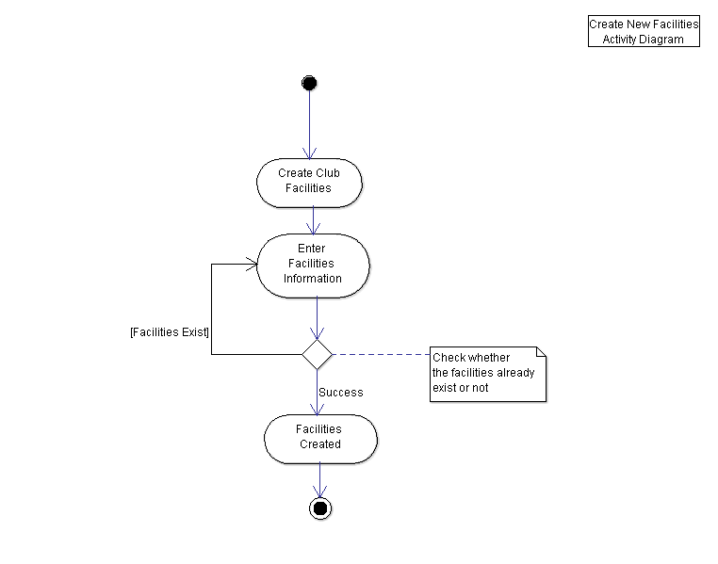

Design Artefacts - Activity Workflows (Iteration 1) #5

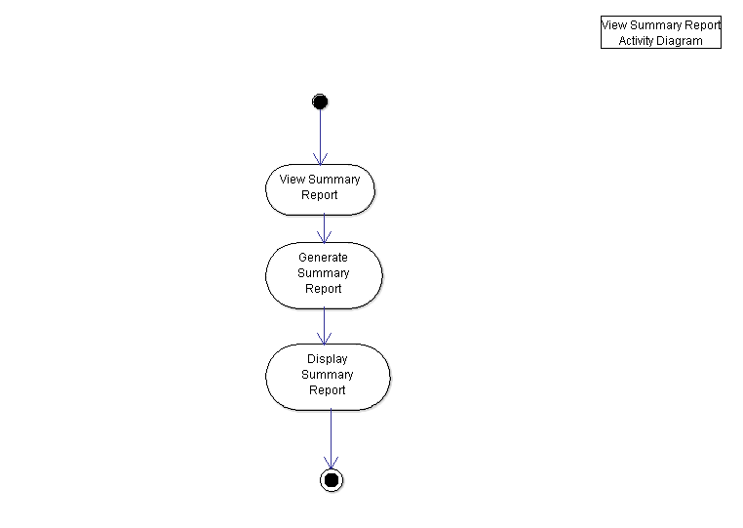

Design Artefacts - Activity Workflows (Iteration 1) #6

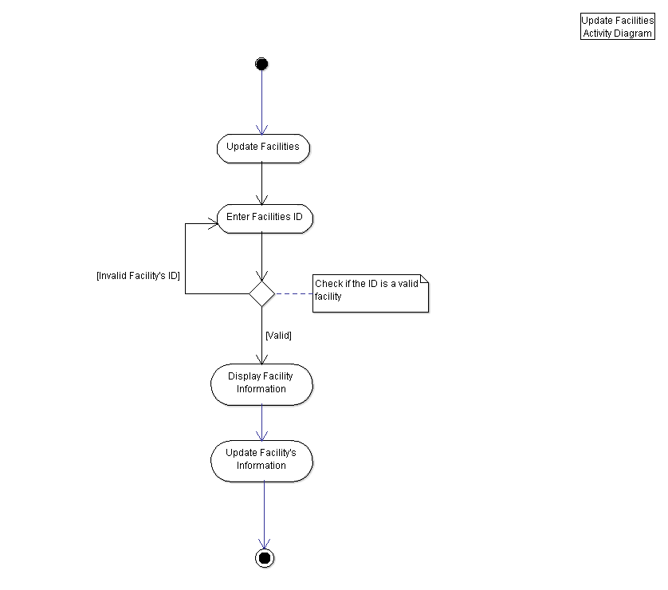

Design Artefacts - Activity Workflows (Iteration 1) #7

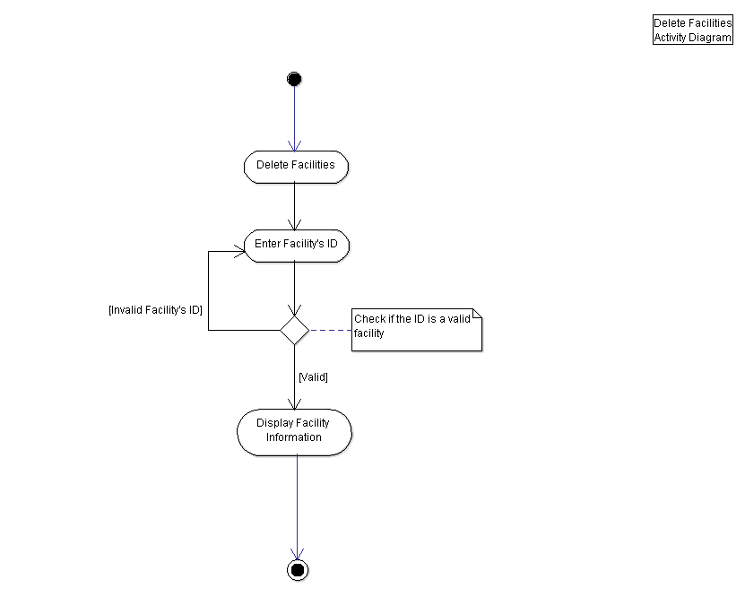

Design Artefacts - Activity Workflows (Iteration 1) #8

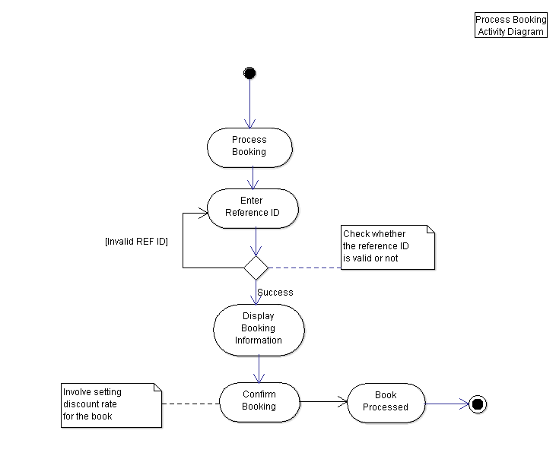

Design Artefacts - Activity Workflows (Iteration 1) #9

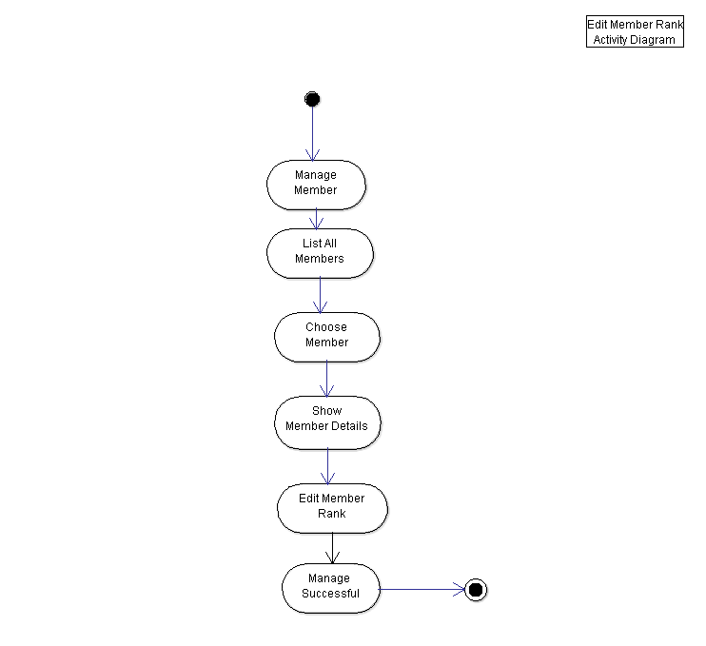

Design Artefacts - Activity Workflows (Iteration 2) #1

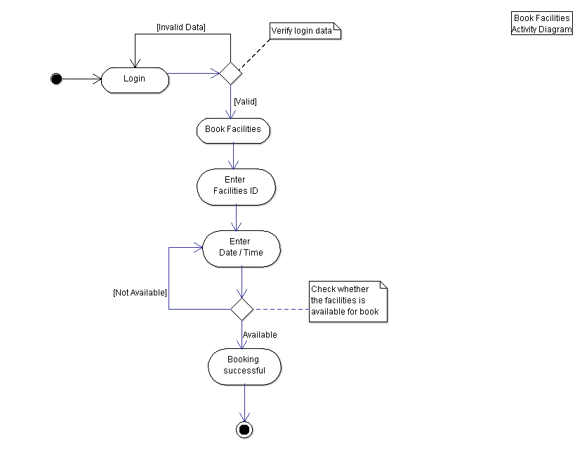

Design Artefacts - Activity Workflows (Iteration 2) #2

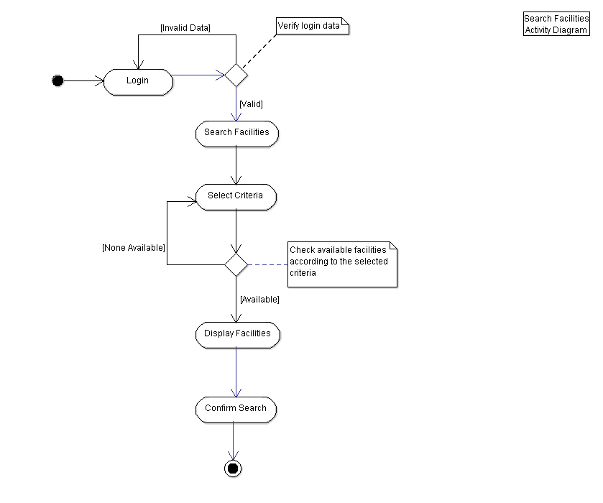

Design Artefacts - Activity Workflows (Iteration 2) #3

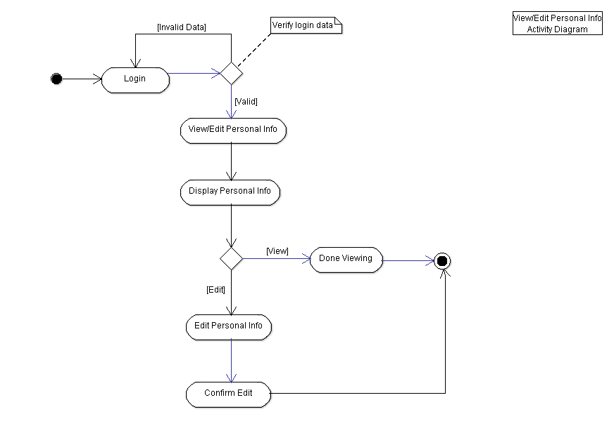

Design Artefacts - Activity Workflows (Iteration 2) #4

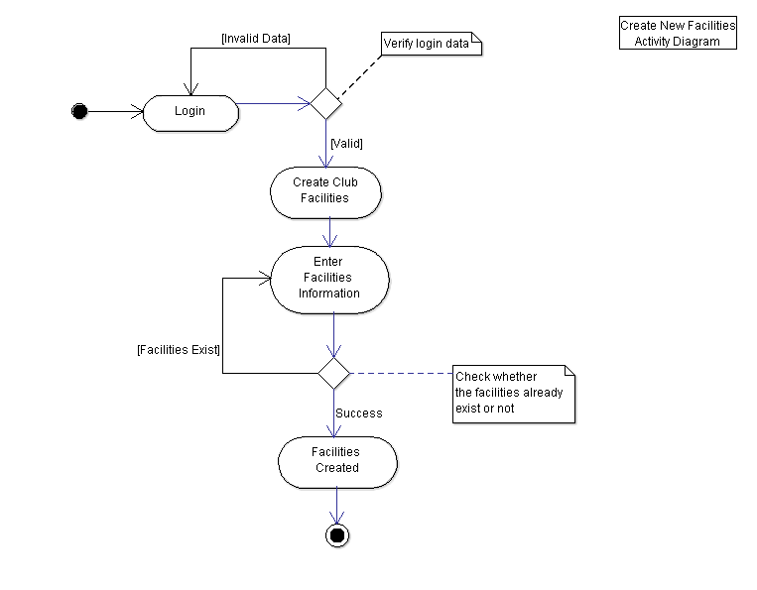

Design Artefacts - Activity Workflows (Iteration 2) #5

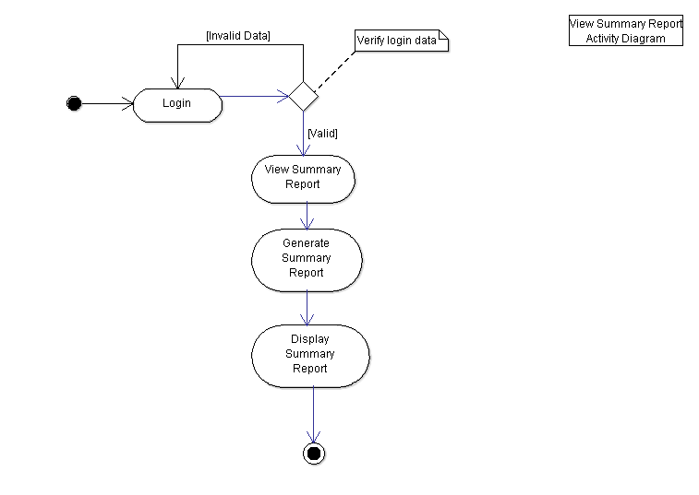

Design Artefacts - Activity Workflows (Iteration 2) #6

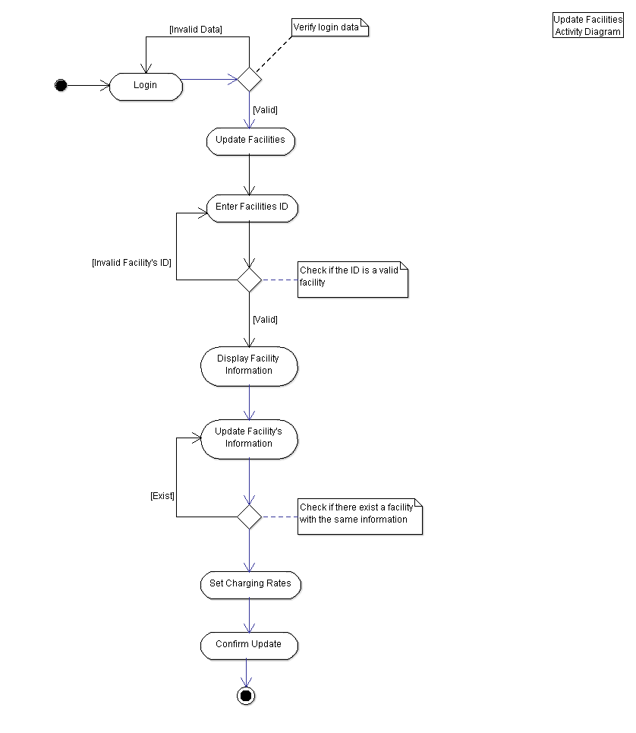

Design Artefacts - Activity Workflows (Iteration 2) #7

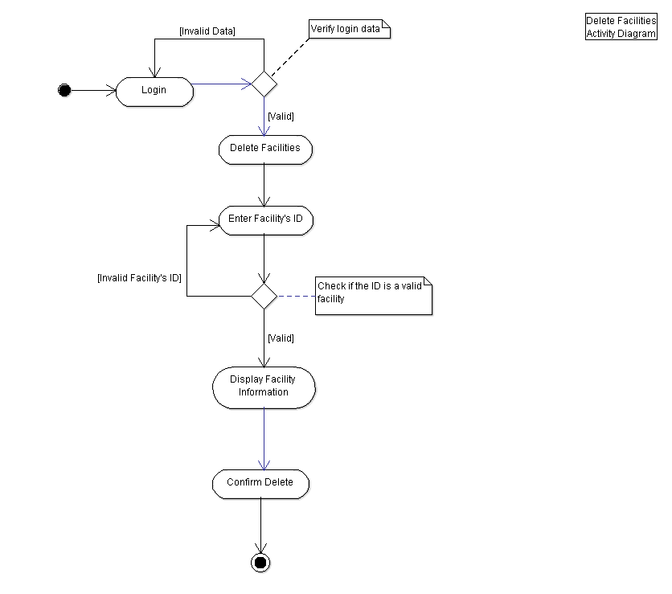

Design Artefacts - Activity Workflows (Iteration 2) #8

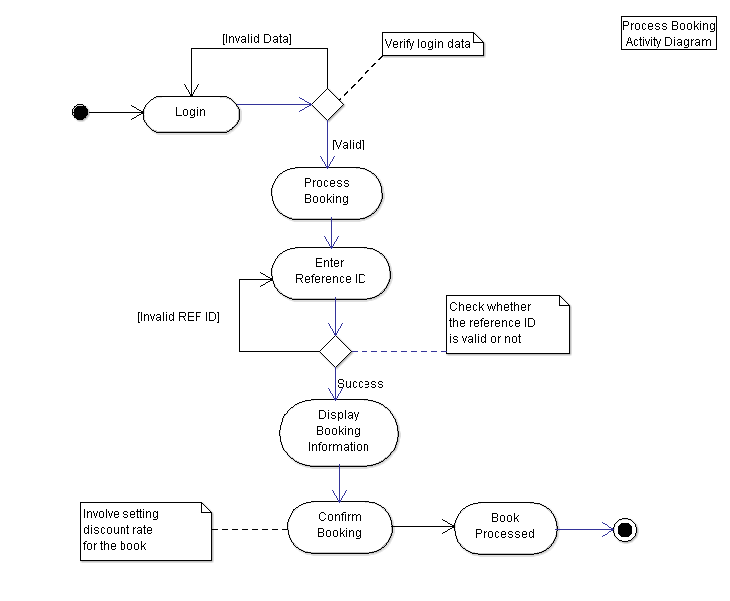

Design Artefacts - Activity Workflows (Iteration 2) #9

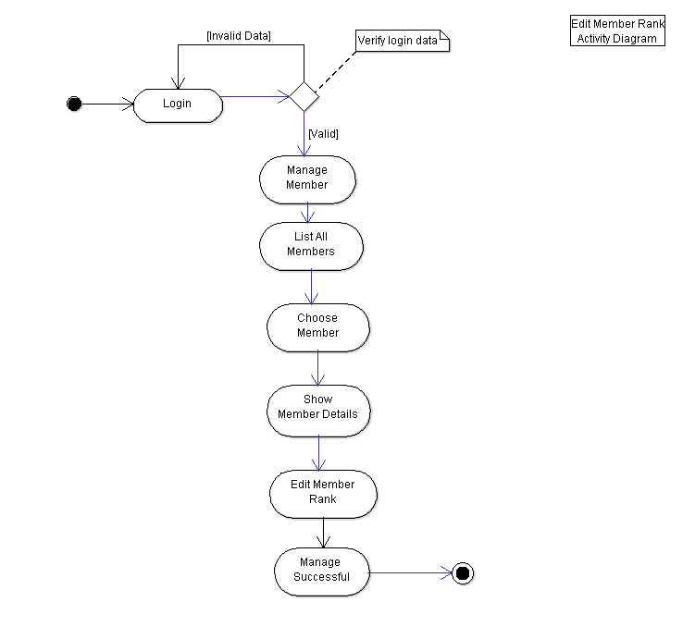

Design Artefacts - Component Diagrams (Iteration 1)

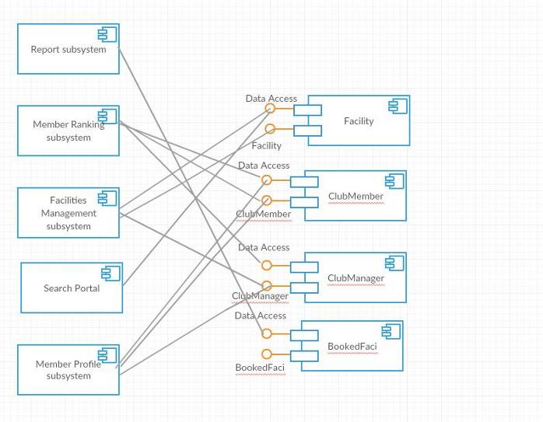

(Any explanation….?)

Design Artefacts - Component Diagrams (Iteration 2)

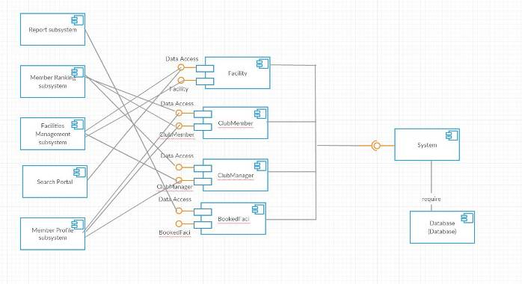

(Any explanation….?)

Design Artefacts - Class Diagrams (Iteration 1)

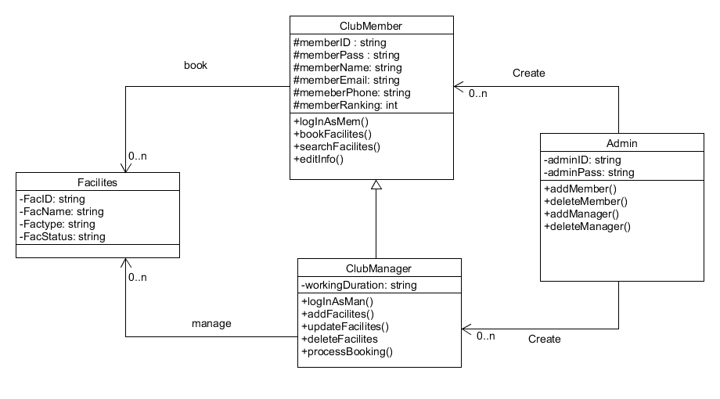

(Any explanation….?)

Design Artefacts - Class Diagrams (Iteration 2)

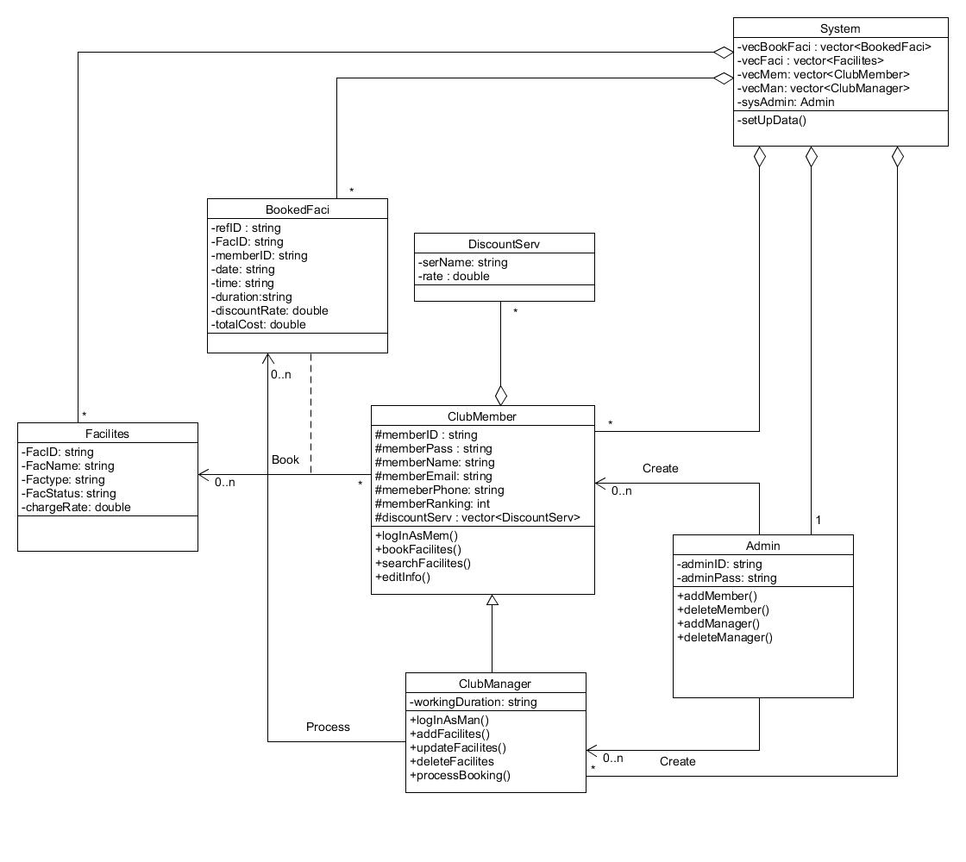
(Any explanation….?)

Appendix A - Formal Meeting Records

Inception Phase - Iteration 1
- Meeting minutes : 120 minutes / 2 hours (13:30 – 15:30)
- Meeting date : January 16th 2016
- Purpose of meeting : Briefing the assignment requirement and assigning the roles of each member
- Meeting summary :
- Discussing the detail of the assignment and outline the project needs.
- Assigning roles and the works to each member.
- Identifying the actors and the classes for the project.
- Establishing which communication tools will be use for the project.

Elaboration Phase - Iteration 1
- Meeting minutes : 160 minutes / 2 hours 40 minutes (15:30 – 18:45 excluding break time)
- Meeting date : January 30th 2016
- Purpose of meeting : Discussing everyone’s works after one week and planning the next work
- Meeting summary :
- Discussing the requirement for the system’s program.
- Reviewing the first version of Use-case diagram and Class diagram.
- Reviewing the first version of Activity diagram and Component diagram.
- Discussing the documentation of the works so far and SRS (System Requirement Specification)

Elaboration Phase - Iteration 2

- Meeting minutes : 160 minutes / 2 hours 40 minutes (15:30 – 18:30 excluding break time)
- Meeting date : February 10th 2016
- Purpose of meeting : Discussing the final version of each diagram and all documents worked so far
- Meeting summary :
- Reviewing all diagrams and identifying any errors.
- Discussing the solution to each problem on all diagrams.
- Briefing the assignment 2 requirement and works.
- Finalizing all the works so far and make a document on each.

Appendix B - Individual Work Diaries

Team Member 1: Nguyen Duc Anh

Inception Phase - Iteration 1
- Meeting minutes : 120 minutes / 2 hours
- Work summary :
- Briefing to team members for the assignment requirement
- Assigning each member roles for the project
- Splitting the work between team members
- Discussing the vision and project overview
- Start working on the Class diagram and help a bit on the Use-case diagram

Elaboration Phase - Iteration 1
- Meeting minutes : 160 minutes / 2 hours 40 minutes
- Work summary :
- Reviewing the first iteration Use-case diagram
- Reviewing the first iteration Class diagram
- Reviewing the first iteration Activity diagram
- Reviewing the first iteration Component diagram
- Fixing all the diagram so far and briefing the work for next week

Elaboration Phase - Iteration 2
- Meeting minutes : 160 minutes / 2 hours 40 minutes
- Work summary :
- Finalizing all the diagram
- Splitting the presentation part to each member
- Discussing the next assignment requirement
- Reviewing and fixing all documents created
- Reviewing the SRS document

Team Member 2: William Wunady

Inception Phase - Iteration 1
- Meeting minutes : 120 minutes / 2 hours
- Work summary :
- Briefed by the team leader about the assignment requirement
- Assigned as the project analyst and sub-manager
- Assigned to work at SRS, scheduling and some part of component diagram
- Discussing the vision and the project overview with the other members
- Documenting the rundown of the group meeting report

Elaboration Phase - Iteration 1
- Meeting minutes : 160 minutes / 2 hours 40 minutes
- Work summary :
- Reviewing the first iteration of the Use-case diagram
- Reviewing the first iteration of the Class diagram
- Reviewing the first iteration of the Activity diagram
- Reviewing the first iteration of the Component diagram
- Working on the requirement list for the project

Elaboration Phase - Iteration 2
- Meeting minutes : 160 minutes / 2 hours 40 minutes
- Work summary :
- Finalizing all the diagram especially the Component diagram
- Starting to work on the presentation slides
- Discussing the next assignment requirement
- Reviewing the SRS with the team leader
- Discussing on the presentation part

Team Member 3: Ardyanto

Inception Phase - Iteration 1
- Meeting minutes : 120 minutes / 2 hours
- Work summary :
- Briefed by the team leader about the assignment requirement
- Assigned as the project designer and sub-analyst
- Assigned to work on Use-case diagram and half of the Activity diagram
- Discussing the vision and the project overview with the other members
- Start working on the first iteration of Use-case diagram

Elaboration Phase - Iteration 1
- Meeting minutes : 160 minutes / 2 hours 40 minutes
- Work summary :
- Reviewing the first iteration of the Use-case diagram
- Reviewing the first iteration of the Class diagram
- Reviewing the first iteration of the Activity diagram
- Reviewing the first iteration of the Component diagram
- Fixing the Use-case diagram and start making the second iteration version

Elaboration Phase - Iteration 2
- Meeting minutes : 160 minutes / 2 hours 40 minutes
- Work summary :
- Finalizing all the diagram particularly the Use-case diagram
- Discussing the next assignment requirement
- Helping the presentation slides
- ???
- ???

Team Member 3: Wu Chin Hwa

Inception Phase - Iteration 1
- Meeting minutes : 120 minutes / 2 hours
- Work summary :
- Briefed by the team leader about the assignment’s requirement
- Assigned as the project analyst and sub-designer
- Assigned to work on the Risk Management Plan and the other half of the Activity diagram
- Discussing the vision and project overview with the rest members
- Identifying the risk of the project and put it into a document

Elaboration Phase - Iteration 1
- Meeting minutes : 160 minutes / 2 hours 40 minutes
- Work summary :
- Reviewing the first iteration of the Use-case diagram
- Reviewing the first iteration of the Class diagram
- Reviewing the first iteration of the Activity diagram
- Reviewing the first iteration of the Component diagram
- Fixing some of the project risk and the Activity diagram

Elaboration Phase - Iteration 2
- Meeting minutes : 160 minutes / 2 hours 40 minutes
- Work summary :
- Making the final version of all diagrams particularly the Activity diagram part with Ardyanto
- Discussing the next assignment requirement
- Working on the assignment report
- Fixing any mistake on all documents (any mistype)
- Revising all the diagram after finished creating the final version

Appendix C - Evidence of using VCS (Version Control Software)

Version Control Software used: TortoiseSVN and Github

Screenshot #1 - Contents in the VCS's Root Folder containing all Repository Project Files

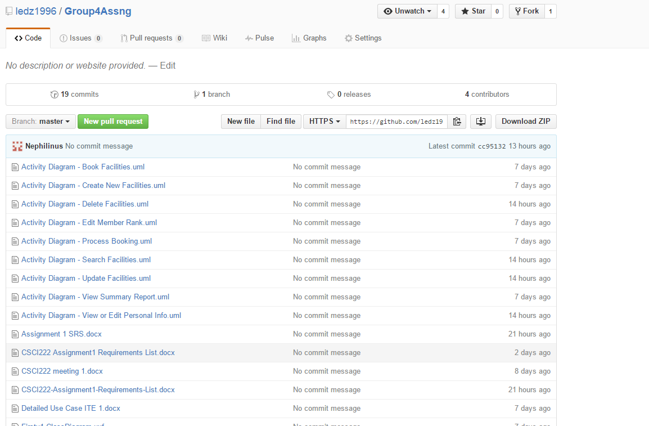

Screenshot #2 - VCS's listing of all the latest source files currently being managed

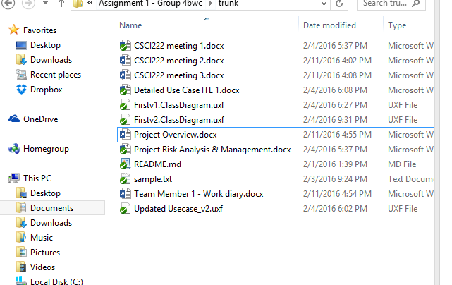

Screenshot #3 - Example using VCS's to check-out source files (it may be necessary to do >1 screen capture, depending on the software used)

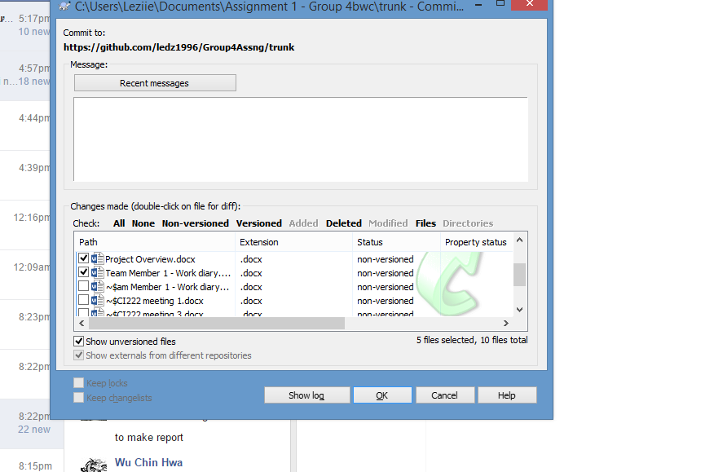
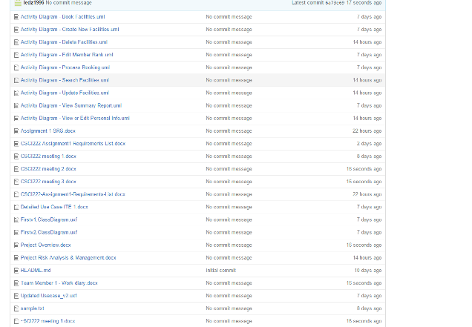

Screenshot #4 - Example using VCS's to check-in source files (it may be necessary to do >1 screen capture, depending on the software used)

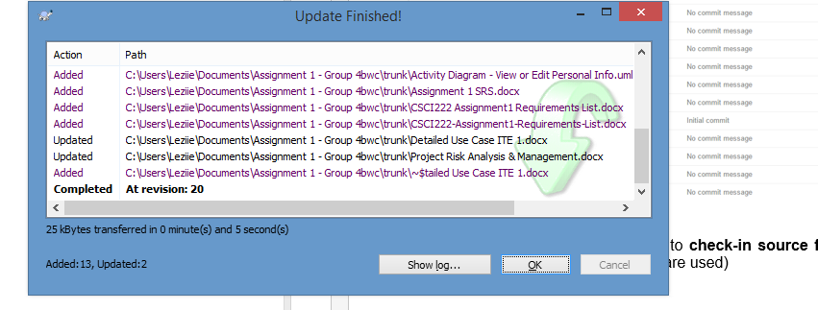
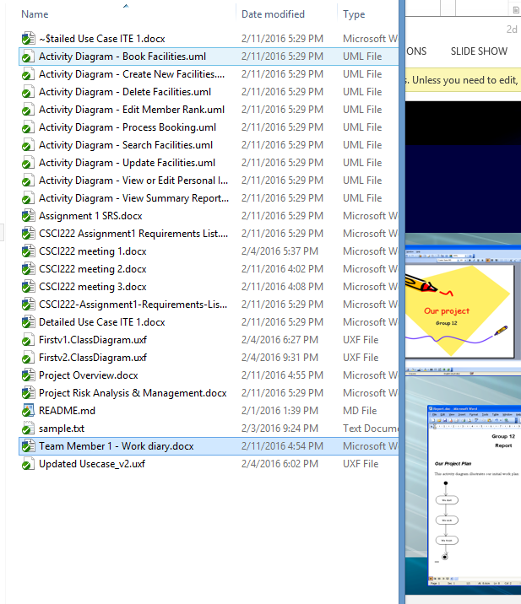

Screenshot #5 - Example using VCS's to display the change history / log (it may be necessary to do >1 screen capture, depending on the software used)

